

**Artificial Intelligence and Data Science Department.**

OOPM / Odd Sem 2021-22 / Experiment.

YASH SARANG.

47 / D6AD.

EXPERIMENT - 6.

**____________________________________________________________**

**AIM:** To write a program to demonstrate multiple inheritance using an interface.

**____________________________________________________________**

**Program 1:**

import java.util.*;

interface Printable

{

void print();

}

interface Showable extends Printable

{

void show();

}

class Interface implements Printable, Showable

{

public void print()

{

System.out.println("Good Morning");

}

public void show()

{System.out.println("Java is the best");

}

public static void main(String args[])

{

Interface obj = new Interface ();

obj.print();

obj.show();

}

}

**The output of program 1:**

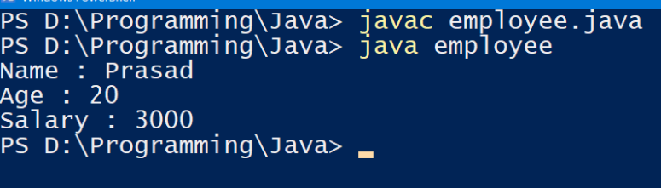

**____________________________________________________________**

**THEORY + CONCLUSION:** 

